PROJECT - REPORT

**I -REVOLUTION: A DATA DRIVEN EXPLORATIONOF APPLE’S I PHONE IMPACT**



TEAM MEMBERS (TEAM ID-NM2023TMID06489

**K.M . SATHISH (asunm1319222104949)**

**M.SIVAKUMAR(asunm1319222104951)**

**P.SELVAKUMAR(asunm1319222104950)**

**R.SIVARAMAN(asunm1319BSCPY2122048)**

PROJECT FLOW:

* DEFINE PROBLEM PROBLEM UNDERSTACTION
* Specify the business problem
* Business requirements
* Literature survey
* DATA COLLECTION AND EXTRACTION
* Collect the data set
* Connect data set with tableau
* DATA PREPARATION
* Prapare the data for visualizations
* DATA VISUALIZATION
* No of unique visualization
* STORY BOARD
* No of scenes of story
* PERFORMANCE TESTING
* Utilization of data filters
* No of calculation fields
* No of visualization graph
* PUBLISHING
* Publishing dashboard and story to tableau public
* PROJECT DEMONSTRATION AND

DOCUMENTATION

* Record explanation video for project end to end solution
* Project documentation step by step project development procedure

# INTRODUCTION

1.1:OVERVIEW:

Apple I phone has been capturing markets around the world .it has emerged as a prominent player among the top smartphone markers

1.2:PURPOSE:

The goal is to shed light on important factors like market penetration customer preference economic ramifications and societal changes this research report will perform a data -driven investigation of the impact of the I phone in India

1. Problem Definition&Design Thinking:

2.1Empathy map:

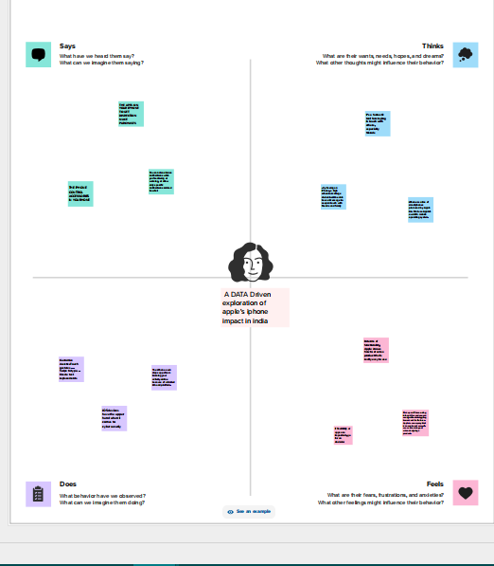

2.2:IDEATION & BRAINSTORME MAP

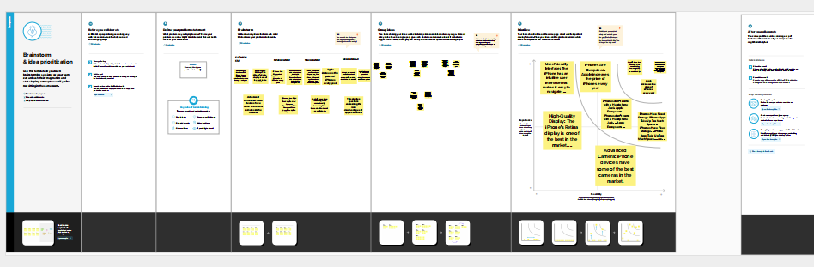

3:RESULT:

Using tableau software we anlysed the data set of I phone market and have created visualization.

**Star rating based on RAM:**

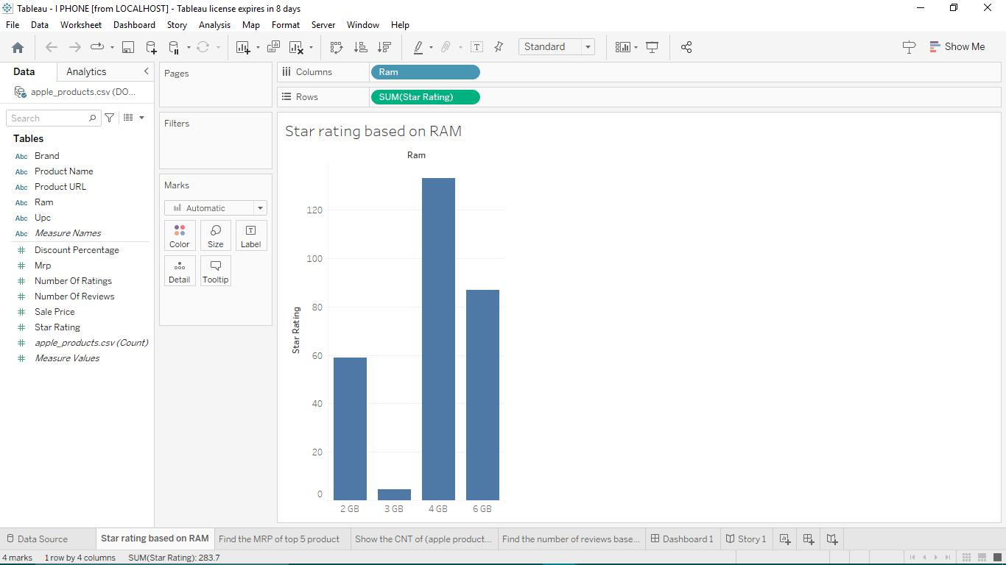

**Find the MRP Of the top product:**

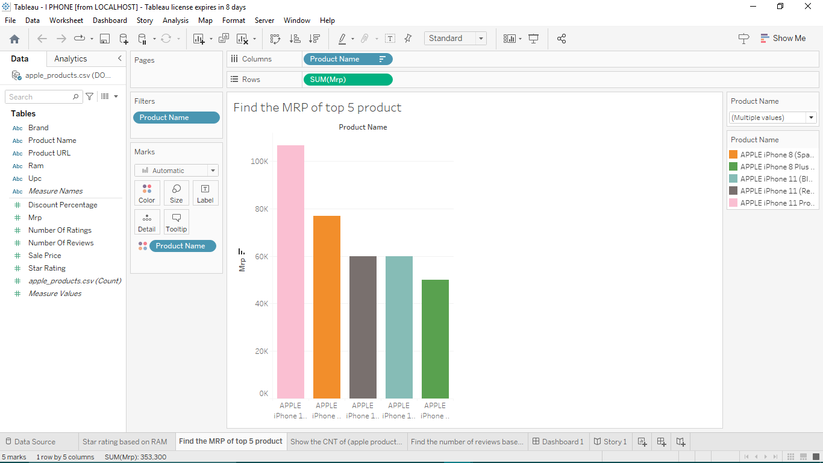

**Show the CNT of (aplle products) based on RAM:**

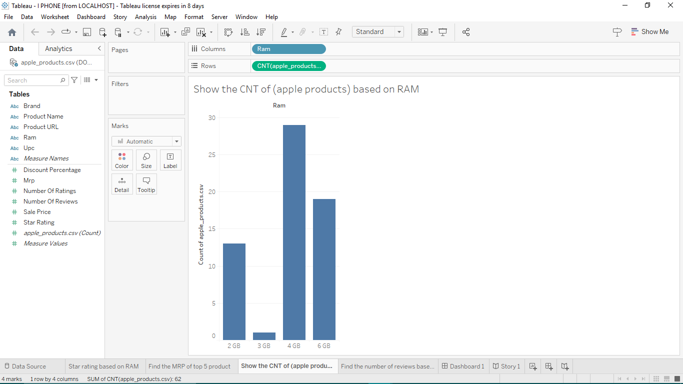

Find the number of reviews based on product URL:

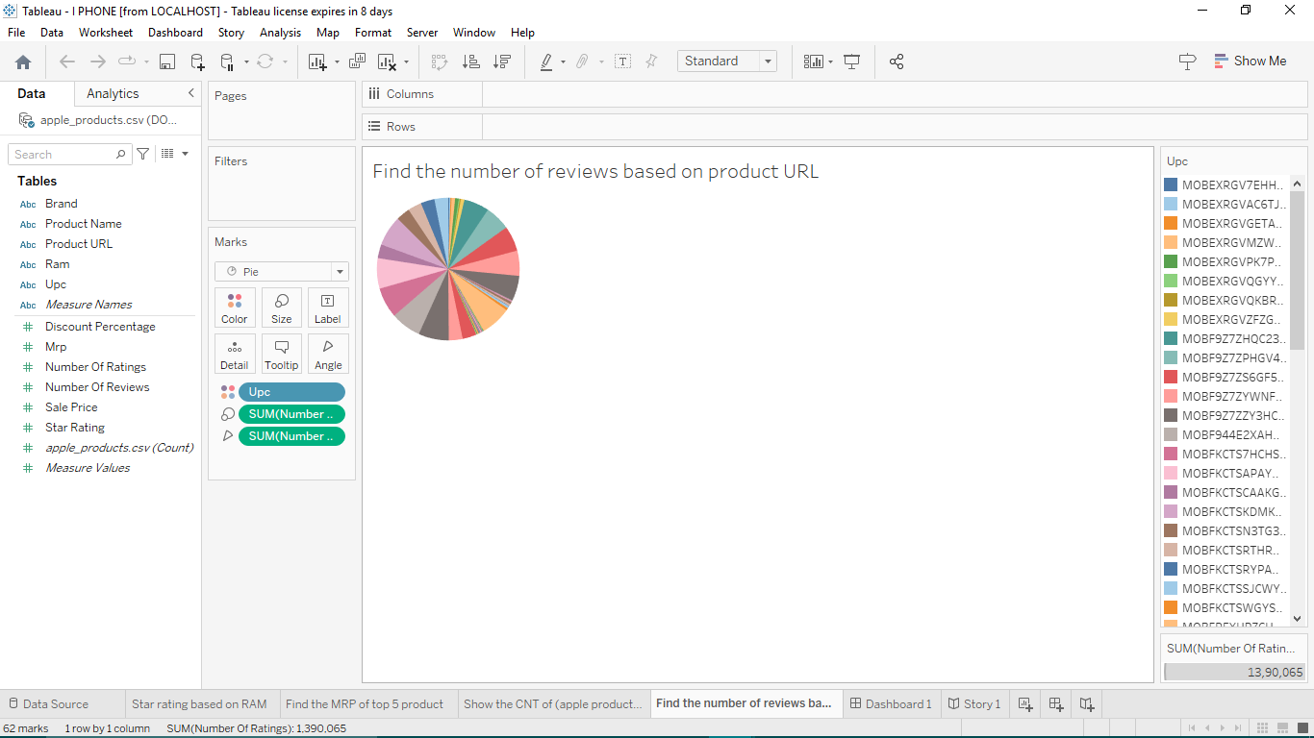

DASHBOARD:

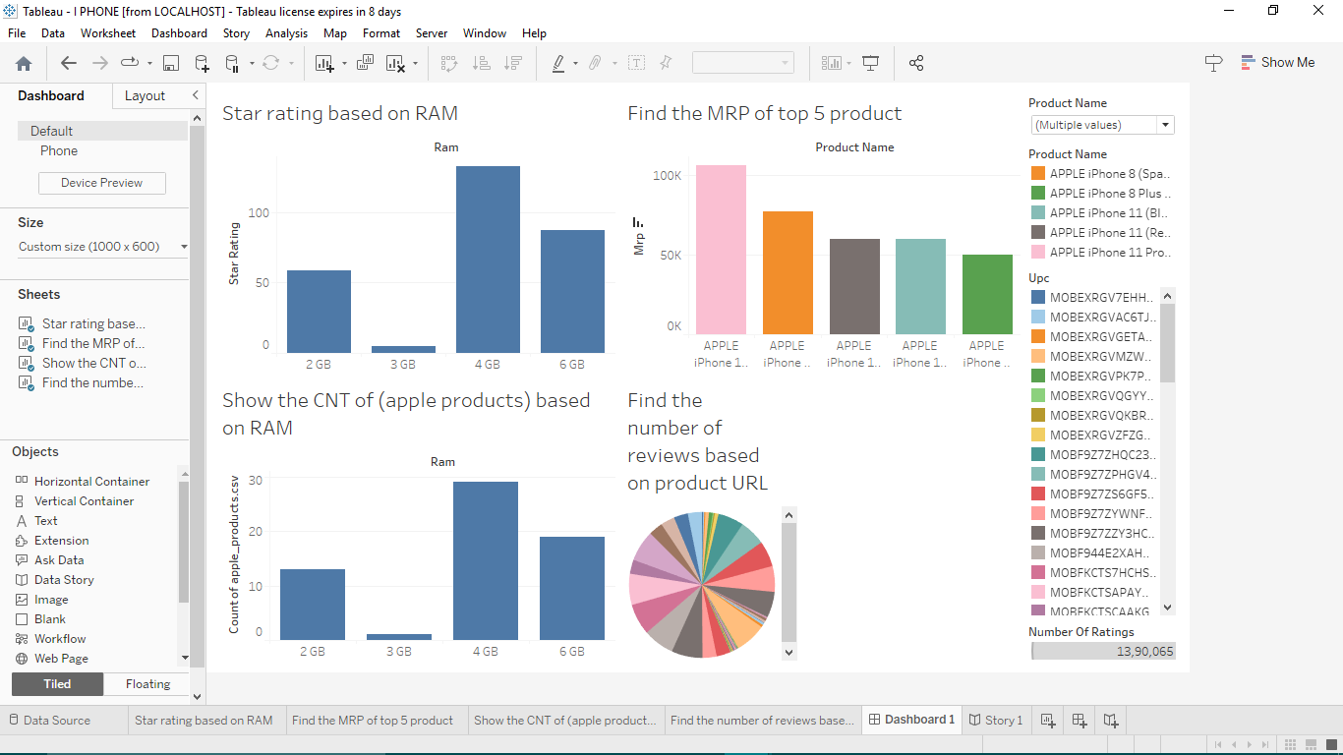

STORY:

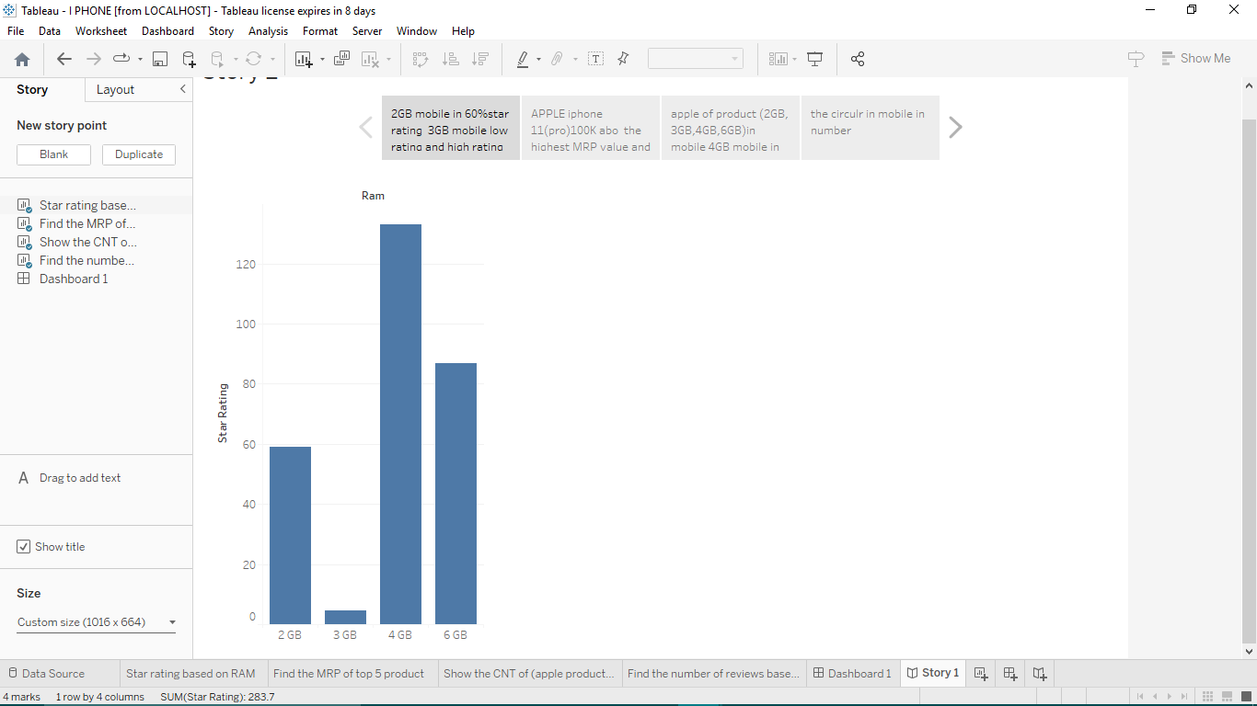

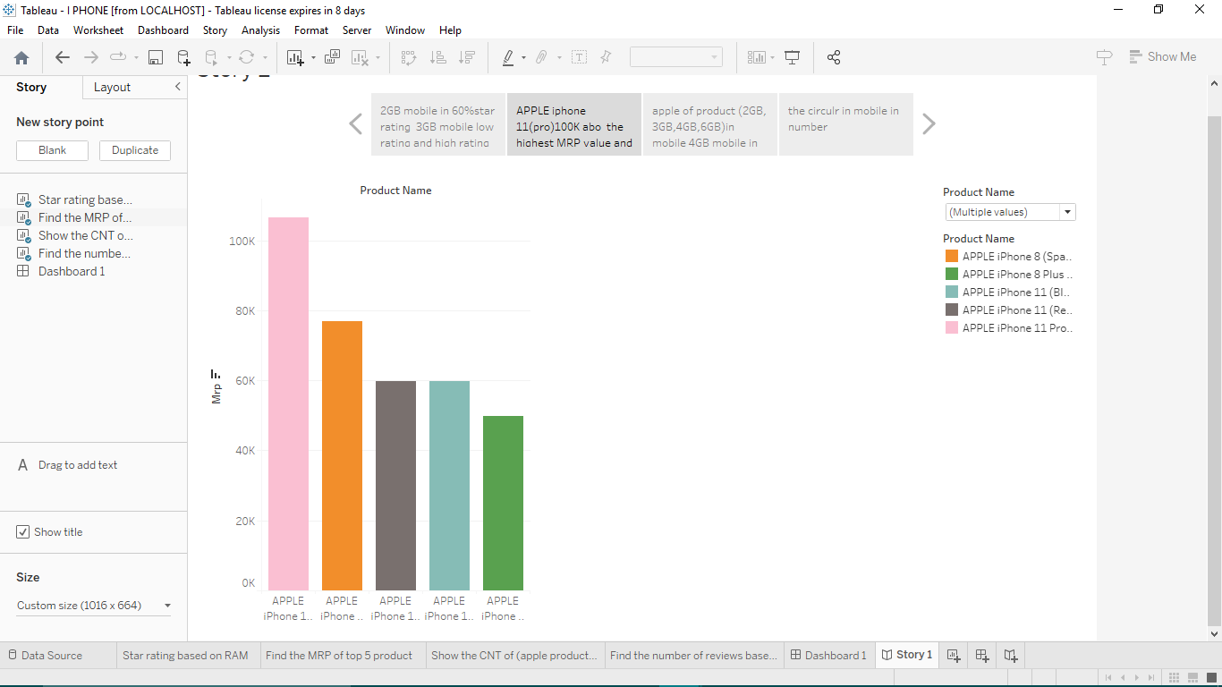

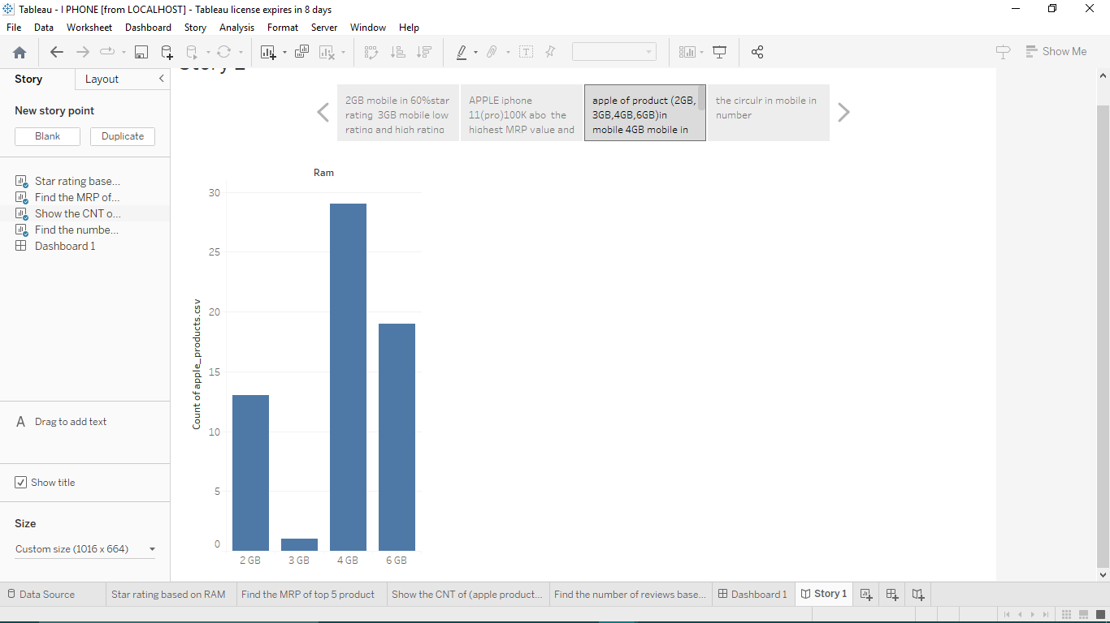

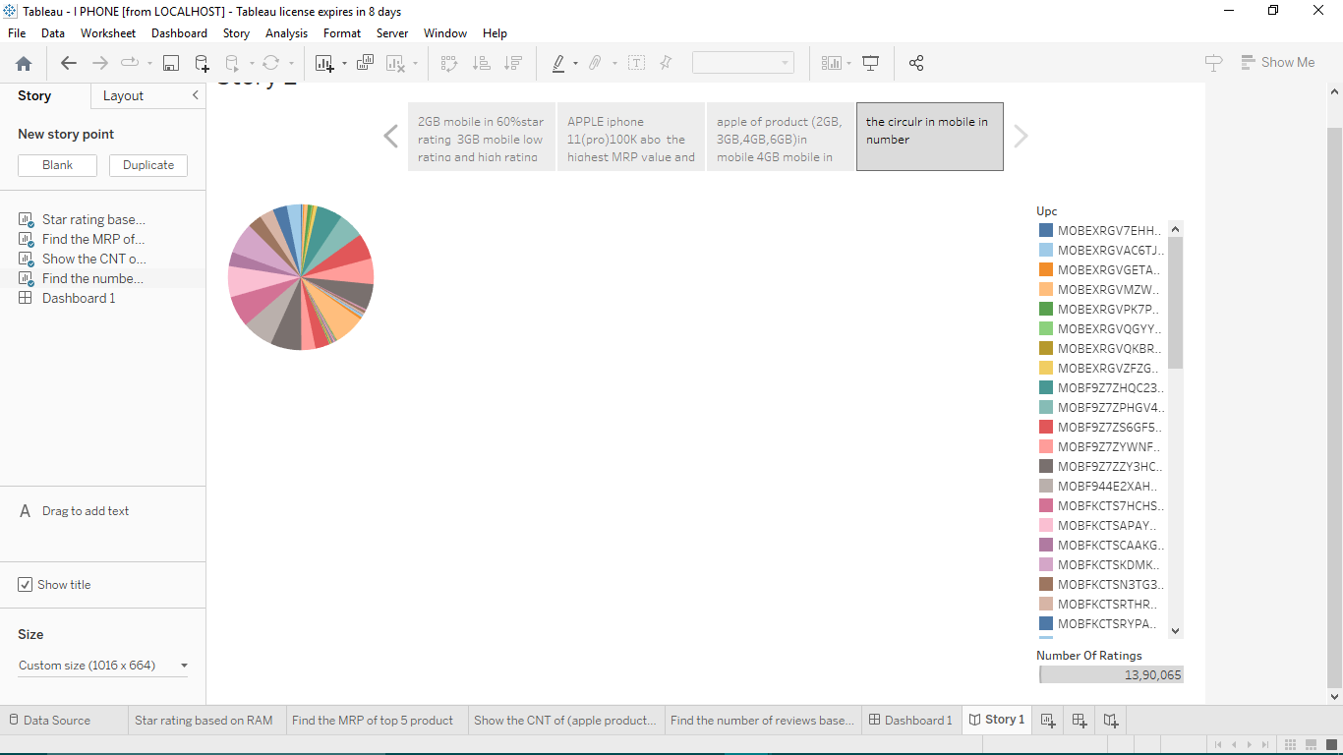

ADVANTAGES AND DISADVANTAGES:

# ADVANTAGES:

* We could explore the apple i phone market in India.
* By tableau app we create visualization’s to analyse data of I phones marketing.

#DISADVANTAGES:

* In India I phones market has not yet made a impact among consumers.
* Iphone’s market has affected other smartphone market revenue in India.

APPLICATIONS:

* By using all these data and analysing the data’s we have learned the market ‘s situationin India .

1. CONCULATION:

Hereby we understand how to use tableau application and analysing the given data. Using tableau application we can create visualizations for easy understanding.

1. FUTURE SCOPE:

We will given the given solution for various problem using data set tableu software.